Technology Trend Report on 3D Printing and Scanning

September 30, 2016
ISO/IEC JTC 1 Plenary (November 2016, Lillehammer, Norway)

Prepared by the ISO/IEC JTC 1 Advisory Group (JAG)
3D Printing and Scanning group

Executive summary
The purpose of this report is to assess the possible contributions of JTC 1 to the global market enabled by 3D Printing and Scanning.

3D printing, also known as additive manufacturing, is considered by many sources as a truly disruptive technology. 3D printers range presently from small table units to room size and can handle simple plastics, metals, biomaterials, concrete or a mix of materials. They can be used in making simple toys, airplane engine components, custom pills, large buildings components or human organs. Depending on process, materials and precision, 3D printer costs range from hundreds to millions of dollars.

3D printing makes possible the manufacturing of devices and components that cannot be constructed cost-effectively with other manufacturing techniques (injection molding, computerized milling, etc.). It also makes possible the fabrications of customized devices, or individual (instead of identical mass-manufactured) units.

3D printing is expected to have a large impact on the economics of global manufacturing. 3D printing, coupled with 3D scanning, also raises significant issues related to international copyright laws.

The data that drives a 3D printer can be generated either by a CAD system or a 3D scanner, or both. This data is machine interpretable and can use an open or proprietary formalism. The formalism might be open-source or proprietary. It needs to be stored, exchanged, indexed, secured, etc. The integrity of the data, especially for safety or mission critical components or devices, must also be ensured.

Together these developments show that many standards and projects for JTC 1 entities are relevant to 3D Printing and Scanning.

This report was produced to support further discussions on this topic by the JTC 1 Advisory Group. Given the potential impact of this IT intensive technology on global commerce, JTC 1 should create and mandate a Study Group to further assess its potential contribution in the area of 3D Printing and Scanning.

Table of contents

Executive summary 2
Table of contents 3
1. Introduction 4
1.1 Purpose and Scope 4
1.2 Methodology 4
2. Terms and definitions 5
3. 3D Printing and Scanning 6
3.1 Introduction 6
3.2 Technology 11
3.3 Market 13
4. IT standardization activities 17
4.1 ISO/TC 261 Additive Manufacturing 18
4.2 ISO/TC 184/SC 4 Industrial Data 20
4.3 IEEE Printer Working Group (PWG) 20
4.4 ASTM Committee F42 on Additive Manufacturing Technologies 22
4.5 ASTM Committee E57 on 3D Imaging Systems 23
4.6 3MF Consortium 23
4.7 Web3D Consortium 24
4.8 JTC 1/SC 24 Computer graphics, image processing and environmental data representation 25
4.9 JTC 1/SC 28 Office equipment 27
4.10 JTC 1/SC 29/WG 11 Coding of moving pictures and audio (MPEG) 27
5. Discussion, gap analysis and opportunities 29
6. Conclusions and Recommendations 31
7. References 32
Annex 1 JTC 1 Systems Integration Matrix 33
Annex 2 IEEE P3030 - Standard for Consumer 3D Printing: Overview and Architecture 34
Annex 3 X3D Graphics for CAD, 3D Printing and 3D Scanning 35
Annex 4 Proposed terms of reference for a JTC 1 Study Group 38
Acknowledgements 39

Introduction

Purpose and Scope
The purpose of this report is to assess the possible contributions of JTC 1 to the global markets enabled by 3D Printing and 3D Scanning.

3D printing, also known as additive manufacturing (AM), refers to various processes used to synthetically produce a physical a three-dimensional (3D) object. In 3D printing, successive layers of material are formed under computer control to create an object. These objects can be of almost any shape or geometry using designs that originate from a 3D model, a 3D scan, or other electronic data source. Since it produces physical objects from digital data, a 3D printer is thus a type of industrial robot [1].

Futurologists such as Jeremy Rifkin believe that 3D printing signals the beginning of a third industrial revolution, succeeding the production line assembly that dominated manufacturing starting in the late 19th century. Using the power of the Internet, it may eventually be possible to send a blueprint of any product to any place in the world to be replicated by a 3D printer, using "elemental inks" capable of being combined into any material substance of any desired form [1].

This document provides an overall review of 3D Printing and Scanning in terms of exploring IT standardization opportunities from the perspective of JTC 1. The JAG Group on 3D Printing and Scanning is making this report based on these review results. Contributions of this report include:
- An overview of 3D Printing and 3D Scanning;
- Analysis of active standardization activities in relevant Standards Development Organizations (SDOs) with an emphasis on information technology (IT);
- Identify potential standardization areas and topics relevant to JTC 1 terms of reference;
- Provide recommendations for continued work by JTC 1.

Methodology
This report was elaborated using by analyzing publicly available information from ISO standards committees, various Web resources, and cooperating SDOs. The earlier technology trend report on 3D Printing and Scanning (ISO/IEC JTC 1/SWG3 N642) by François Coallier was used as basis document for this report. This report was finalized through the teleconferences from May 2016 to September 2016 where the experts from the following NBs participated; Canada, France, Japan, Korea, UK and US.

Terms and definitions
3D printing or Additive Manufacturing: (AM) is any of various processes for making a three-dimensional object of almost any shape from a 3D model or other electronic data source primarily through additive processes in which successive layers of material are laid down under computer control[2]. A 3D printer is a type of industrial robot [1].

3D scanning: 3D scanning is a process using a device that analyzes a real-world object or environment to collect data on its shape and possibly its appearance (i.e. color). The collected data can then be used to construct digital three-dimensional models [2].

According to ISO/ASTM 52900:2015, “Additive manufacturing is the general term for those technologies that, based on a geometrical representation, create physical objects by successive addition of material. These technologies are presently used for various applications in engineering industry as well as other areas of society, such as medicine, education, architecture, cartography, toys and entertainment.”

Using the terms and definitions of ISO/ASTM 52900:2015, the following terms are defined more precisely:

Additive manufacturing
AM
process of joining materials to make parts (2.6.1) from 3D model data, usually layer (2.3.10) upon layer, as opposed to subtractive manufacturing and formative manufacturing methodologies

Note 1 to entry: Historical terms: additive fabrication, additive processes, additive techniques, additive layer manufacturing, layer manufacturing, solid freeform fabrication and freeform fabrication.

Note 2 to entry: The meaning of “additive-”, “subtractive-” and “formative-” manufacturing methodologies are further discussed in Annex A.

3D printing
fabrication of objects through the deposition of a material using a print head, nozzle, or another printer technology

Note 1 to entry: Term often used in a non-technical context synonymously with additive manufacturing (2.1.2); until present times this term has in particular been associated with machines that are low end in price and/or overall capability.

3D scanning
3D digitizing
method of acquiring the shape and size of an object as a 3-dimensional representation by recording x, y, z coordinates on the object’s surface and through software the collection of points is converted into digital data.

Note 1 to entry: Typical methods use some amount of automation, coupled with a touch probe, optical sensor, or other device.

Additive Manufacturing processes are defined as: “processes of joining materials to make objects from 3D model data, usually layer upon layer, as opposed to subtractive manufacturing fabrication methodologies.” [ASTM 2792-12]

Additive Manufacturing is also referred to as [9]:
- Generative Manufacturing – Germany
- eManufacturing – Germany
- Constructive Manufacturing – Germany
- Additive Layer Manufacturing (ALM) – Scandinavia & EADS
- Direct Digital Manufacture (DDM) – USA
- Freeform Fabrication (FFF) – USA
- Solid Freeform Fabrication (SFF) – USA
- 3D Printing (3DP) – Global
- Rapid Manufacturing – Global (historic)

Digital Thread is a corresponding global area of interest, which considers changes to overall manufacturing processes and logistics that occur as a result of Additive Manufacturing and related capabilities refactoring of global supply chain.

3D Printing and Scanning

Introduction
Additive Manufacturing (AM) is defined as the direct production of finished goods using additive processes from digital data (EU, SASAM, 2016). It is a process of making a three-dimensional solid object of virtually any shape from a digital model. It uses an additive process, where materials are applied in successive layers. In contrast, subtractive manufacturing processes usually start with larger sources and successively remove unwanted materials.

A key advantage is that AM typically eliminates the need for tooling, such as molds and dies, that can make the introduction of new products prohibitively expensive, both in time and money. AM enables the production of forms that have been long considered impossible by conventional series production, in fact, they can be created fast, flexibly, and with fewer machines.
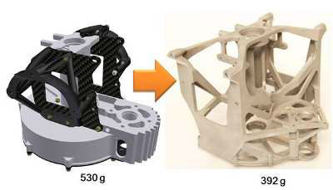
Figure 1 Comparing traditional and additive manufacture of a specific part

3D printing, also known as additive manufacturing, is considered by many sources as a truly disruptive technology. 3D printers range presently from small table units to room size and can handle simple plastics, metals, biomaterials, drugs, concrete or a mix of material. They can be used in making simple toys, pills with custom drug mixtures and dosage, airplane engine components, large building components or even human organs. 3D printer costs range from a few hundred to a few million dollars.

3D printing makes possible the manufacturing of devices and components that are not possible to construct with traditional manufacturing techniques. It also makes possible the fabrications of customized devices, or individual (instead of identical mass-manufactured) units. Occasionally 3D printing is used to create custom molds that are subsequently applied to traditional construction processes using alternative materials that themselves might not be suitable for 3D printing.

The 3D printing market has the potential to significantly improve and refactor supply-chain efficiency, reducing time to market, enabling mass customization, and supporting environmental sustainability [10].

3D printing capabilities have the potential to reduce the costs of storing, moving, and distributing raw materials, mid-process parts and end-usable parts. The ability to produce parts on demand without the need for expensive specialty tooling and setup can become a basis for new solutions in supply chain management.

Time-to-market durations are expected to shrink in the 3D printing applications due to faster design and prototyping cycles, more-predictable factory loading, and the elimination of special tooling and factory-setup times for new products. Increased freedom to design and redesign prototypes and parts without slowing down or adding to production costs also enables a more fluid product development process. Similarly, the ability of machines to read CAD files improves production planning. Systems can accurately predict the time and material requirements necessary to build a part before it is on a machine, and then can measure volume and track excess capacity at any moment.

3D printing’s flexibility to employ multiple designs on the same machine can enable the manufacturing industry to move from mass production in factories to mass customization with distributed manufacturing. Using materials ranging from plastic to titanium to human cells, additive manufacturing creates intricate products of a near-infinite variety that can be made to exact customer specifications.

3D printing can further become a multifaceted tool for mitigating environmental impact by replacing many of the casting, molding and other manufacturing processes that consume significant amounts of energy and produce expensive (or hazardous) industrial waste. The technology also imposes few constraints on product design, enabling previously separate parts to be consolidated into a single object with increased functionality while reducing the amount of energy and natural resources.
3D printing thus enables significant impacts on the economics of global manufacturing. 3D printing, coupled with 3D scanning, also raises issues related to international copyright laws.

The data that drives a 3D printer can be generated by a CAD system, a 3D scanner, or both together. This data is machine interpretable and may include open or proprietary formalisms. Indeed either the printable model or the data-format itself might be open-source or proprietary. Such data is often sensitive and needs to be carefully stored, exchanged, indexed, secured, etc. The integrity of the original data must also be ensured, especially for mission-critical components and safety devices.

The 3D printing process starts with the development of a digital 3D model or data set containing the complete geometrical information. A 3D printer continues with the transformation of such data into a physical model, layer by layer. Thus the 3D printing process begins several steps before the 3D printer actually kicks into action.

The whole process is initiated when a user has an abstract image of an object in mind that he intends to 3D print. The next step is to find appropriate software that can model the particular object in digital form in 3D and will provide the 3D printer’s built-in software (also called firmware) with the required input data. Computer-aided design (CAD) software or the scan of an existing artifact can be used to create a 3D model of an object. Alternatively, the user can search various extensive databases online for a suitable existing design file.

Once a design is ready, the user typically translates the design file into a special geometric file format such as STL, which the control software of the printer can read and work with. When a design file is converted to STL, the software transforms the entire surface of the digital model into a mesh of connected triangles. When the STL conversion is complete, the volume of the newly wrapped object is completely enclosed by the generated mesh.

In the next step, a software program known as a slicer, converts the mesh into a series of commands to create the model layer by layer. Depending on the printing technology, these commands may activate a light source to harden or fuse target material or command a print head to extrude material while moving to a given location. These commands are what are transmitted to the printer and interpreted by the printers firmware. For stereolithography, and fused deposition modeling the most common of these command sets is known as G-code. The G-code language was originated in the 1950s for controlling CNC machines and Pen plotters. While there is an existing standard (EIA Standard RS-274) for G-code the hobbyist and consumer markets have extended the language in occasionally incompatible ways. Therefore, further standardization with G-code may be necessary (https://en.wikipedia.org/wiki/G-code).

ISO 17296-4:2014 shows the general overview of traditional data flow from product idea to actual part as in below.

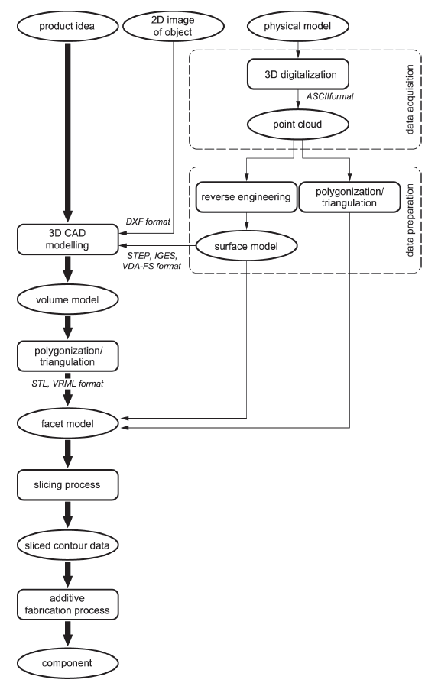
Figure 2 Traditional data flow from product idea to actual part

3D Scanning is an accurate and fast method which determines the shape of an entity’s surface or its volume in a 3-dimensional space. 3D Scanners are the devices which capture 3D information about the real-world objects, thereby helping in 3D visualization and measurement. The 3D models can be used extensively to perform comparative and dimensional analysis of a product or can be used to make changes in design to give rise to a new product. 3D Scanning is an emerging technology and is expected to show promising outgrowth in the near future [12].

3D scanners capture and measure geometry of physical object or environment by using lasers or structured light. Due to high volume and approximation of surfaces, data captured by these 3D scanners are often called “point clouds.” Such large datasets are used by software to create 3D representation of the scanned object or physical environment for in-depth analysis, inspection, and modification. Precision and accuracy both vary widely and depend on sensor fidelity, scanning procedures and the ability of software to correlate numerous point approximations into smooth meshes. 3D scanners find wide application across several industries, currently with varying product quality [13].

Technology
A large number of additive processes are now available. The main differences between processes are in the way layers are deposited to create parts and in the materials that are used. Some methods melt or soften the material to produce the layers, for example, selective laser melting (SLM) or direct metal laser sintering (DMLS), selective laser sintering (SLS), fused deposition modeling (FDM), or fused filament fabrication (FFF), while others cure liquid materials using different sophisticated technologies, such as stereolithography (SLA). With laminated object manufacturing (LOM), thin layers are cut to shape and joined together (e.g., paper, polymer, metal). Each method has its own advantages and drawbacks, which is why some companies offer a choice of powder and polymer for the material used to build the object [1].

Additional details about 3D printing technology are provided in Table 1.

Table 1 3D Printing Technologies

Type | Technologies | Materials
Extrusion | Fused deposition modeling (FDM) or Fused Filament Fabrication (FFF) | Thermoplastics, eutectic metals, edible materials, Rubbers, Modeling clay, Plasticine, Metal clay (including Precious Metal Clay)
 | Robocasting or Direct Ink Writing (DIW) | Ceramic materials, Metal alloy, cermet, metal matrix composite, ceramic matrix composite
Light polymerized | Stereolithography (SLA) | Photopolymer
 | Digital Light Processing (DLP) | Photopolymer
Powder Bed | Powder bed and inkjet head 3D printing (3DP) | Almost any metal alloy, powdered polymers, Plaster
 | Electron-beam melting (EBM) | Almost any metal alloy including Titanium alloys
 | Selective laser melting (SLM) | Titanium alloys, Cobalt Chrome alloys, Stainless Steel, Aluminium
 | Selective heat sintering (SHS) | Thermoplastic powder
 | Selective laser sintering (SLS) | Thermoplastics, metal powders, ceramic powders
 | Direct metal laser sintering (DMLS) | Almost any metal alloy
Laminated | Laminated object manufacturing (LOM) | Paper, metal foil, plastic film
Powder Fed | Directed Energy Deposition | Almost any metal alloy
Wire | Electron beam freeform fabrication (EBF) | Almost any metal alloy

Some 3D scanner types are classified as laser and structured light 3D scanners. Product segmentation covers tripod mounted, automated and coordinate measuring machine (CMM) based, and handheld/desktop/stationary 3D scanners. 3D Scanning technologies include Laser Scanners, White Light Scanning devices, Photogrammetry devices, Machine Vision Devices, Coordinate Measuring Machines, X-ray computed tomography (CT) or Magnetic Resonance Imaging (MRI) scanners, and others. The various kinds of scanners used are primarily based on the varied sensing technologies available.

3D scanners can be put to extensive use across a varied range of applications such as Reverse Engineering, Inspection, Digital Archiving, Rapid Prototyping, Topographical Surveys and so on. Well-established fields such as Automotive, Aerospace, Education, Architecture, Medical, Dental and others are among the various end-user industries that employ 3D Scanning for topological visualizations.

Market
As seen in Figure 3, Gartner in 2015 was considering Enterprise 3D Printing as fairly mature while Consumer 3D Printing and 3D Bioprinting Systems are not yet mature.
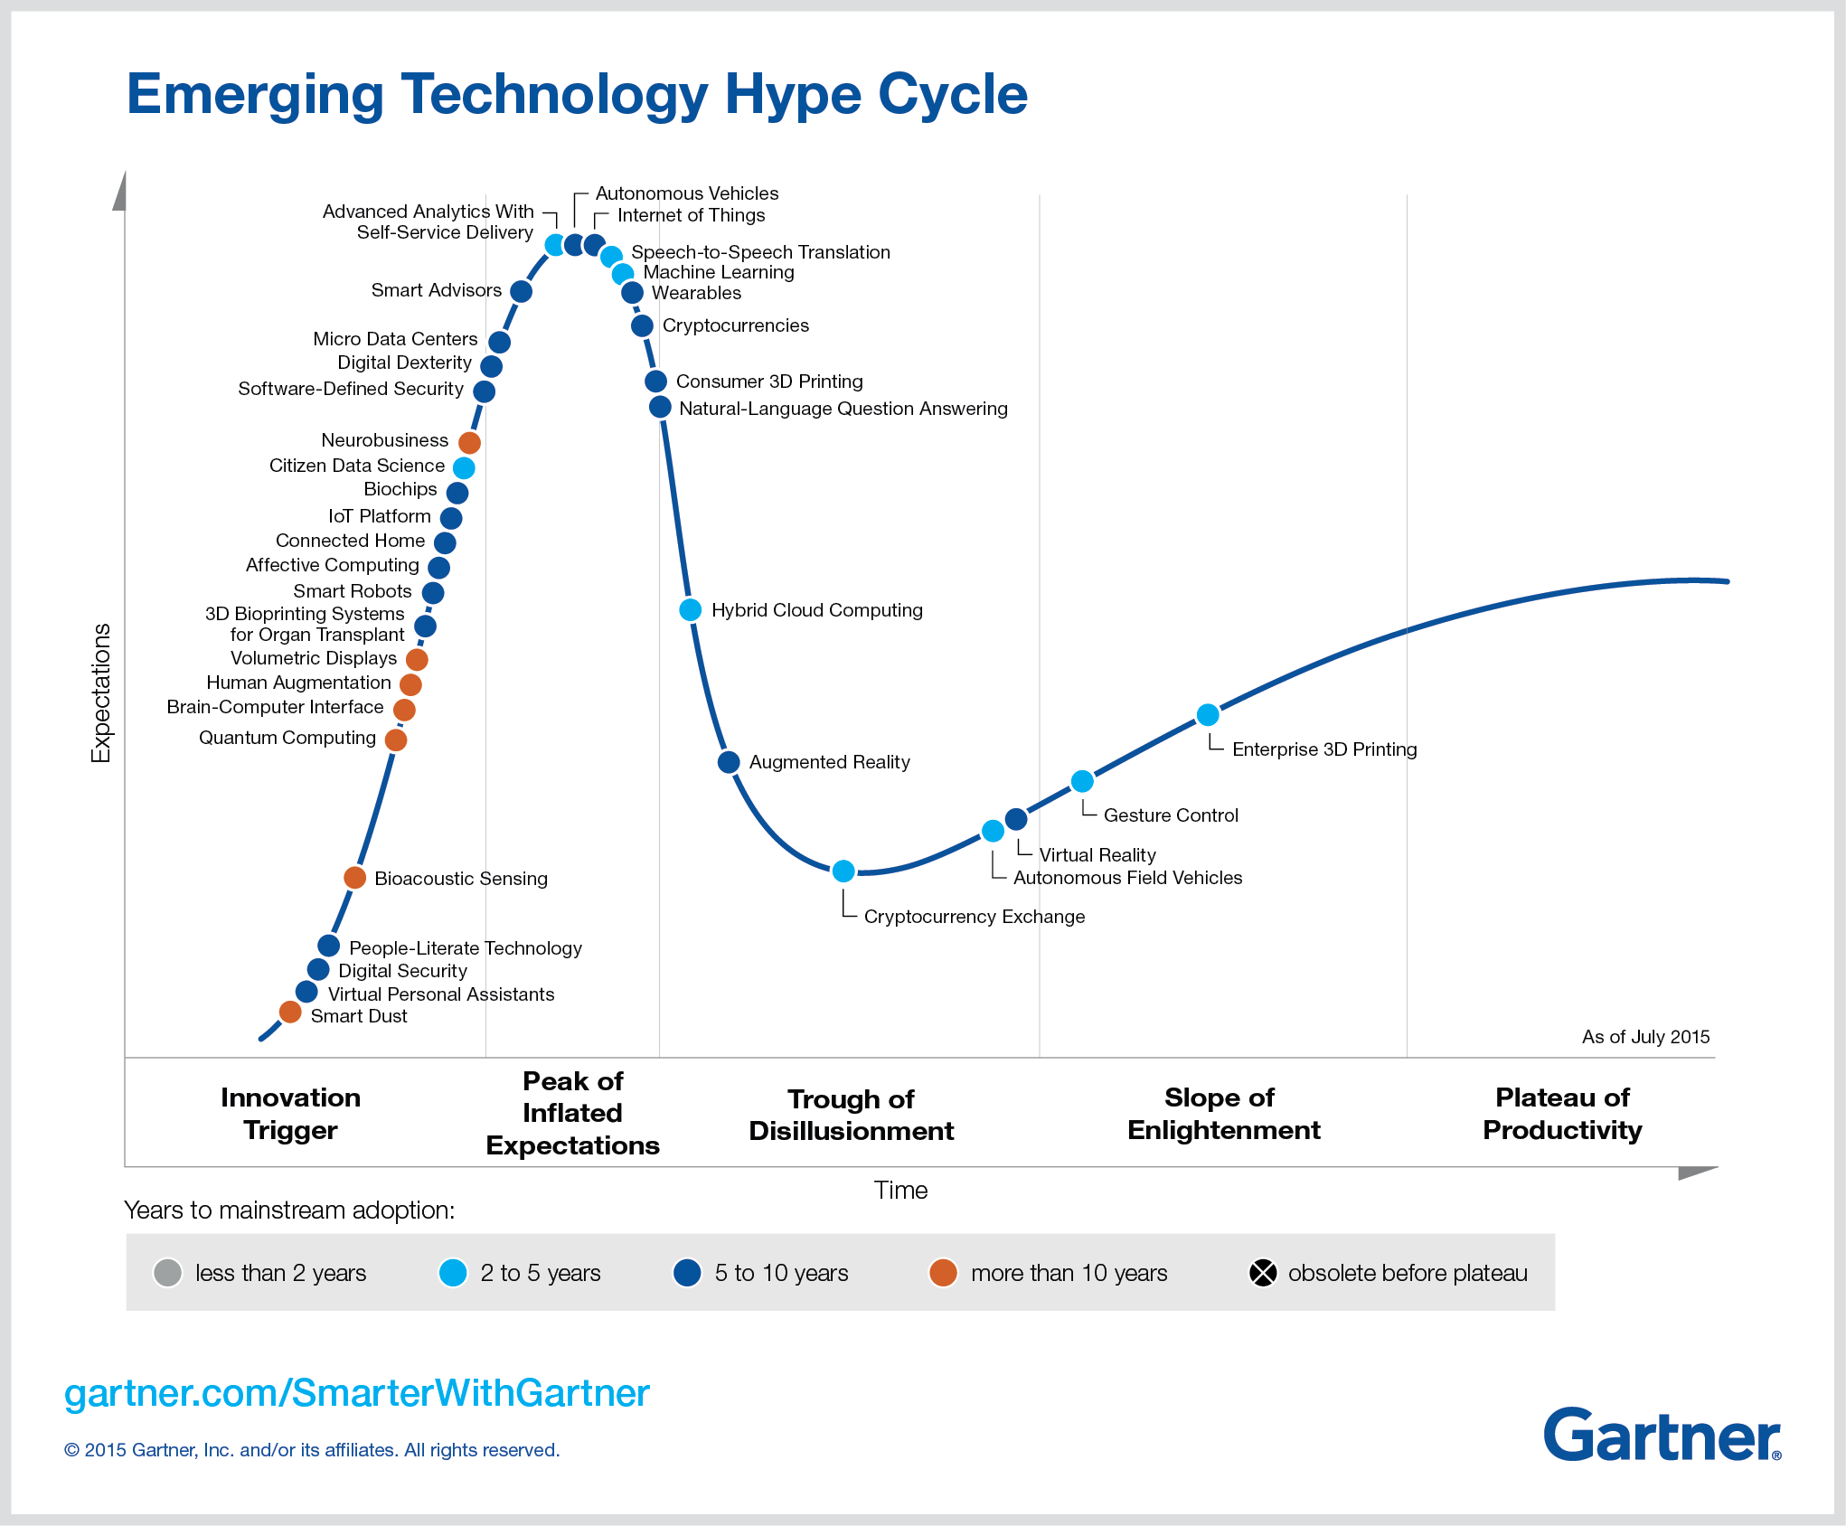

Figure 3 General maturity of 3D Printing and 3D Scanning on 2015 Gartner Hype Cycle

As mentioned, 3D printing has a wide range of applications. The Gartner diagram of Figure 4 is interesting in this regard since it places various applications of 3D printing at different levels of maturity on its “hype cycle.” According to Gartner, many applications are at early stages of innovation while others have already reached the plateau of productivity.

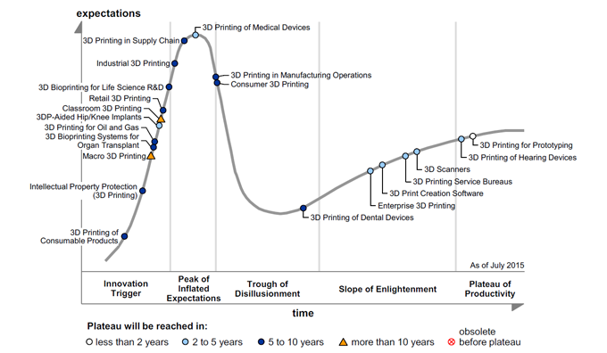
Figure 4 Gartner 2015 Hype Cycle for 3D printing

Many estimates of the potential size of the 3D printing market are available in the open online literature. Figure 5 summarizes some of them.

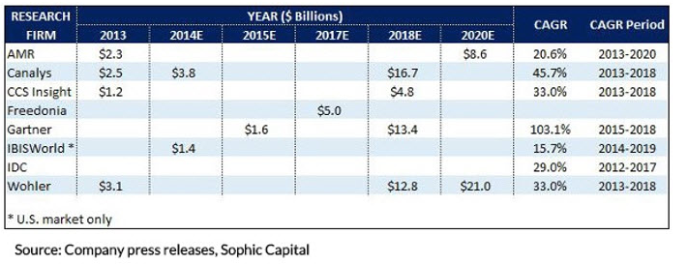
Figure 5 Comparative table of Global 3D Printing Market estimations

This shows a market that appears to be growing at a fast pace. Figure 6 shows one of these market estimates in more detail, while also illustrating the complexity of the technology for both materials as well as the different ‘printing’ processes used.

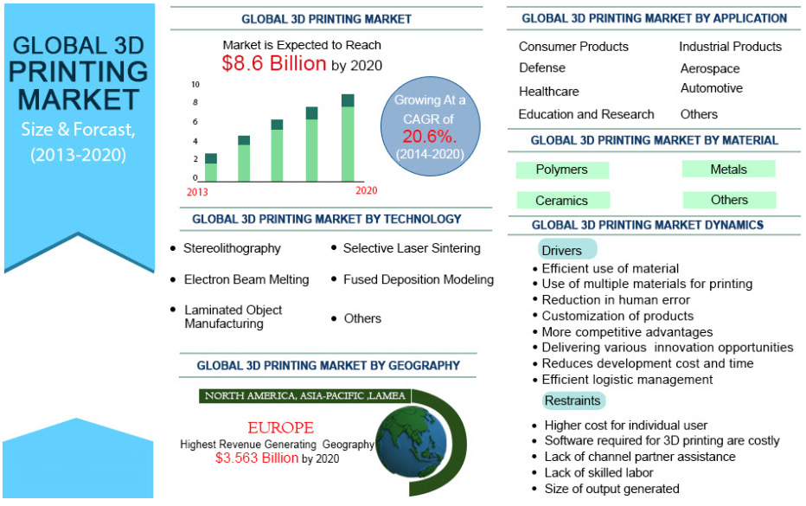
Figure 6 Estimation of the Global 3D Printing Market

The consumer market is changing rapidly. On the growth side consumer grade 3D printers have accounted for over $10M in crowdfunded startups and they are becoming prolific in libraries and schools. On the down side many companies are struggling to identify a segment for profitability with two of the early consumer printer startups having ceased operation.

Potential impact of 3D printing on different markets is further illustrated in Figure 7.

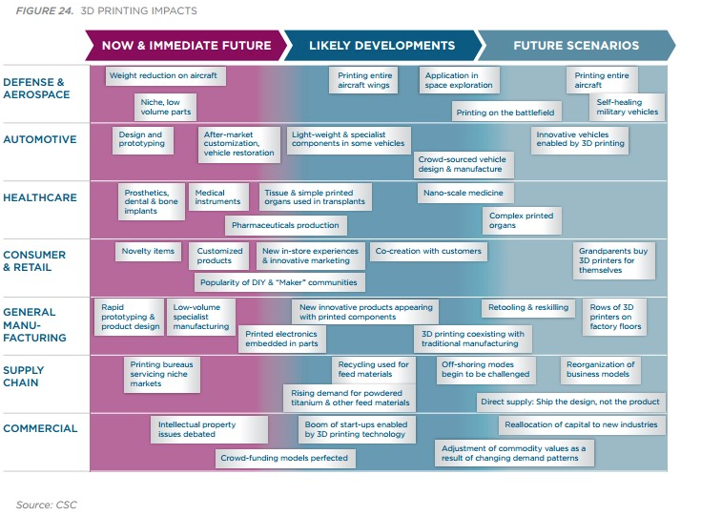
Figure 7 3D printing impact on various industries

Figure 8 shows that the global 3D Scanner and Printer market is actually quite fragmented, with industry players that are very different from the traditional office and commercial printing markets.

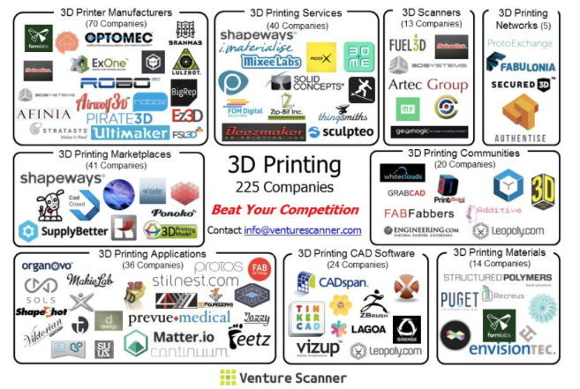
Figure 8 3D Scanning and Printers companies

While 3D printing is beginning to be used for a range of different manufacturing functions, it has not yet reached a mass market. At present, only serious enthusiasts or highly specialized manufacturers use 3D printers. Given the rapid pace of progress, everyone may soon find themselves consuming products created by 3D printers.

In practice, 3D printing will not create a single, homogenous market; it will most likely be used in a variety of different ways, giving rise to different types of businesses and different approaches to manufacturing. The most significant likely markets involved in 3D printing include [11]:

- Design – 3D printing will likely create a global market for digital designs, both for generic blueprints and bespoke (custom) design services;
- Bespoke manufacturing services – 3D printing may well place increased emphasis on the service aspect of manufacturing, with retail and production being fused into customized services;
- Home 3D printing – Some 3D printing is likely to take place within the home, while some will take place within shops or factories; these domestic and commercial markets will look very different;
- Manufacture of 3D printers – Producing and servicing 3D printers themselves are likely to be a big-money industry; and
- Materials – Creating and sourcing materials for use in 3D printers will also become a significant market.

So far, this report has mainly looked at the market for 3D Printing that is quite closely related to the 3D Scanning but there are other market for 3D Scanning that is not necessarily related to 3D Printing.

Because of its usefulness in making dummy parts and prototypes for manufacturing, 3D scanning will continue to be in high demand for the automotive and similar mechanical sectors, while quality control, cultural heritage and reverse engineering will become major growth applications for the technology in the years to come [14].

The 3D scanning market is also being driven by the fact that it is being widely adopted by the medical industry for surgical applications, diagnosis via MRI, CT scan and others, while it is also being used in dentistry. Moreover, a recent story revealed how a 3D scanner is being used by Australian police to map crime scenes without disturbing evidence [14].

IT standardization activities
Currently, 3D Printing and 3D Scanning standardization activities occurs in the following organizations:

- ISO TC 261 Additive manufacturing
- ISO/TC61 – Plastic
- ISO/TC106 – Dentistry
- ISO/TC119 - Powder Metallurgy
- ISO/TC172/SC9 – Electro–optical systems
- ISO/TC184/SC4 - Industrial Data
- IEEE Printer Working Group (PWG)
- IEEE C3DP – Consumer 3D Printing Working Group
- IEEE 3D Based Medical Application Working Group (3DMA WG)
- ASTM Committee F42 on Additive Manufacturing Technologies
- ASTM Committee E57 on 3D Imaging Systems
- 3MF Consortium
- DICOM – Digital Imaging and Communications in Medicine
- Khronos 3D Format Working Group
- CIE(International Commission on Illumination) Division 8(Image Technology)
- Web3D Consortium
- JTC 1/SC24
- JTC 1/SC28
- JTC 1/SC29/WG11

ISO/TC 261 Additive Manufacturing
ISO/TC 261 terms of references are:
Standardization in the field of Additive Manufacturing (AM) concerning their processes, terms and definitions, process chains (Hardware and Software), test procedures, quality parameters, supply agreements and all kind of fundamentals.

It has the following groups that might be of interest to JTC 1:

- ISO/TC 261/WG 1 Terminology
- ISO/TC 261/WG 4 Data and Design
- ISO/TC 261/JAG ISO/TC 261 - ASTM F42 Steering group on JWG activities
- ISO/TC 261/AHG 3 Monitoring of data representation standards
- ISO/TC 261/AHG 4 Medical requirements on AM

As of May 2016, six standards have been published by this organization:

- ISO 17296-2:2015 Additive manufacturing -- General principles -- Part 2: Overview of process categories and feedstock
- ISO 17296-3:2014 Additive manufacturing -- General principles -- Part 3: Main characteristics and corresponding test methods
- ISO 17296-4:2014 Additive manufacturing -- General principles -- Part 4: Overview of data processing
- ISO/ASTM 52900:2015 Additive manufacturing -- General principles -- Terminology
- ISO/ASTM 52915:2013 Standard specification for additive manufacturing file format (AMF) Version 1.1
- ISO/ASTM 52921:2013 Standard terminology for additive manufacturing -- Coordinate systems and test methodologies

Noteworthy and pertinent to this report topic is standard ISO 17296-4:2014 listed above. Its content is summarized as follows:

ISO 17296-4:2014 covers the principal considerations which apply to data exchange for additive manufacturing. It specifies terms and definitions which enable information to be exchanged describing geometries or parts such that they can be additively manufactured. The data exchange method outlines file type, data enclosed formatting of such data and what this can be used for.

ISO 17296-4:2014 enables a suitable format for data exchange to be specified, describes the existing developments for additive manufacturing of 3D geometries, outlines existing file formats used as part of the existing developments, and enables understanding of necessary features for data exchange for adopters of the International Standard.

ISO 17296-4:2014 is aimed at users and producers of additive manufacturing processes and associated software systems. It applies wherever additive processes are used, and to the following fields in particular: production of additive manufacturing systems and equipment including software; software engineers involved in CAD/CAE systems; reverse-engineering systems developers; and test bodies wishing to compare requested and actual geometries.

Specifically, in section 4.1.2.2 on 3D digitalisation (reverse engineering) describes this as a process in which the surface geometry of a physical object is measured using appropriate hardware and software and recorded in a digital point cloud model. The objects may be manually produced or finished models which need to be copied in digital form. The use of 3D digitalisation is particularly efficient if the model has empirically drafted, freeform surface areas, since these are difficult to reproduce through direct 3D CAD modelling.

The following standards are also under development:

- ISO/ASTM DIS 52910 Standard Practice – Guide for Design for Additive Manufacturing
- ISO/ASTM DIS 52901 Additive manufacturing -- General principles -- Requirements for purchased AM parts
- ISO/ASTM DIS 52903-1 Additive Manufacturing -- Standard Specification for Material Extrusion Based Additive Manufacturing of Plastic Materials -- Part 1: Feedstock materials
- ISO/ASTM NP 52092 Additive manufacturing -- General principles -- Standard test artifacts
- ISO/ASTM CD 52903-2 Additive manufacturing -- Standard specification for material extrusion based additive manufacturing of plastic materials -- Part 2: Process -- Equipment
- ISO/ASTM CD 20194 Additive manufacturing -- General principles -- Requirements for purchased AM parts
- ISO/ASTM FDIS 52915 Specification for additive manufacturing file format (AMF) Version 1.2

ISO/ASTM DIS 52910 Standard Practice – Guide for Design for Additive Manufacturing (previously known as ISO/DIS 20195) indicates in Section 7.10 File Source — CAD vs. CT. — There are a number of file sources used to generate STL and AMF files including scanned data and CAD. Errors can occur due to CT-slice scan thickness and resolution, point cloud quality from scanners, and similar resolution limitations from other sources of scanned data. Designers need to understand the quality of files being used to design components intended for AM.

ISO/TC 184/SC 4 Industrial Data
ISO/TC 184/SC 4 has developed and maintains ISO standards that describe and manage industrial data throughout the life of the product. Its work includes modelling of industrial, technical and scientific data to support electronic communication and commerce. Among them, ISO 10303 is an ISO standard for the computer-interpretable representation and exchange of product manufacturing information. Its official title is: “Automation systems and integration - Product data representation and exchange.” It is known informally as "STEP", which stands for "Standard for the Exchange of Product model data". ISO 10303 can represent 3D objects in Computer-Aided Design (CAD) and related information.

According to [18], ISO/TC 184/SC 4 Plenary made the resolution to establish a new working group on "Digital Manufacturing" related to 3D Printing and Scanning. The scope of new WG is:

To identify and where necessary develop a coherent set of Industrial Data Standards maximizing efficiency for the realization of digital products including the areas of digital control, digital planning, digital monitoring, digital simulation, digital validation and digital inspection, in full cooperation with other standards development organizations.

Currently ISO/TC 184/SC 4 has liaison with many ISO/IEC JTC1/SCs such as SC 7, SC 24, SC 31, SC 32 and SC 34.

IEEE Printer Working Group (PWG)
The IEEE PWG presents itself as follows:

The Printer Working Group (PWG) is a Program of the IEEE Industry Standard and Technology Organization (ISTO) with members including printer and multi-function device manufacturers, print server developers, operating system providers, print management application developers, and industry experts. Originally founded in 1991 as the Network Printing Alliance, the PWG is chartered to make printers, multi-function devices, and the applications and operating systems supporting them work together better.

It has currently four active working groups, none on 3D printing. This topic is currently under investigation, as stated on the Web site (http://www.pwg.org/3d/) as of August 24 2015:

The Printer Working Group is investigating standardization of 3D Printing using the Internet Printing Protocol and PWG Semantic Model for the underlying network protocol and Job Ticket formats, and one or more existing high-level 3D file formats to describe the objects to print.

A white paper was published on 2015-08-12, essentially defining ‘an extension to the Internet Printing Protocol that supports printing of physical objects by Additive Manufacturing devices such as 3D printers.’

It is interesting to note that, according to this organization,’ While IPP and the PWG Semantic Model can be easily adapted to 3D printing, adapting the existing 3D file formats is proving to be more of a challenge.’

Four 3D file formats are enumerated on the Web page on 3D printing http://www.pwg.org/3d:

- 3D Manufacturing File Format (3MF): 3MF offers a slightly more compact XML format than AMF with physical dimensions, named materials, and shared vertices. The OPC (ZIP) format it uses may pose resource issues for low-end printer controllers, and little existing 3D software supports the format.

- Additive Manufacturing File Format (AMF): AMF is an ISO standard XML format that supports physical dimensions, named materials, and shared vertices. It is generally considered to be the replacement for STL and is supported by some 3D software.

- Collada (DAE): COLLADA defines an XML Namespace and database schema to make it easy to transport 3D assets between applications without loss of information, enabling diverse 3D authoring and processing tools to be combined into a content production pipeline. COLLADA is standard format defined by Khronos Group and also ISO standard – ISO/PAS 17506 (CAD format).

- Stereo Lithography File Format (STL): STL is the current de facto-standard file format with both plain text and binary encodings. While it is the most widely used and supported file format for 3D printing, it lacks support for physical dimensions, materials and colors, metadata, or shared vertices.

The IEEE PWG web site was updated and two formats are now presented as “IPP 3D File Formats”: 3MF and PDF with the following description:
- PDF: PDF 1.7 (ISO 32000-1) includes 3D support using the Universal 3D format ("U3D", ECMA-363) and PDF 2.0 (ISO 32000-2) will add support for the Product Representation Compact format ("PRC", ISO 14739-1:2014) format. Both U3D and PRC are binary file formats with named materials. PRC also includes manufacturing tolerance metadata. PDF is a recommended file format for the IPP 3D Printing Extensions.

This information is pertinent to JTC 1 since 3D Scanning is considered as well as 3D printing.

ASTM Committee F42 on Additive Manufacturing Technologies
The ASTM Committee F42 on Additive Manufacturing Technologies scope is (http://www.astm.org/COMMIT/SCOPES/F42.htm):

The promotion of knowledge, stimulation of research and implementation of technology through the development of standards for additive manufacturing technologies. The work of this Committee will be coordinated with other ASTM technical committees and other national and international organizations having mutual or related interests.

It has the following sub-committees:

- F42.01 Test Methods
- F42.04 Design
- F42.05 Materials and Processes
- F42.06 Environment, Health, and Safety
- F42.90 Executive
- F42.91 Terminology
- F42.94 Strategic Planning
- F42.95 US TAG to ISO TC 261

Of possible interest to is the following project:

WK48549 New Specification for AMF Support for Solid Modeling: Voxel Information, Constructive Solid Geometry Representations and Solid Texturing

ASTM Committee E57 on 3D Imaging Systems
The ASTM Committee E57 on 3D Imaging Systems scope is (http://www.astm.org/COMMIT/SCOPES/E57.htm):

The development of standards for 3D imaging systems, which include, but are not limited to laser scanners (also known as LADAR or laser radars) and optical range cameras (also known as flash LADAR or 3D range camera).
The initial focus will be on standards for 3D imaging system specification and performance evaluation for applications including, but not limited to:
• Construction and Maintenance
• Surveying
• Mapping and Terrain Characterization
• Manufacturing (e.g., aerospace, shipbuilding, etc.)
• Transportation
• Mining
• Mobility
• Historic preservation
• Forensics

It has the following sub-committees:

- F57.01 Terminology
- F57.02 Test Methods
- F57.03 Guidelines
- F57.04 Data Interoperability
- F57.90 Executive
- F57.91 Strategic Planning and Marketing

Of possible interest to is the following standard:

E2807-11 Standard Specification for 3D Imaging Data Exchange, Version 1.0

3MF Consortium
The 3MF Consortium presents itself as follows (http://www.3mf.io/about-us/overview):

Launched in 2015, the 3MF Consortium, a Joint Development Project, is an industry consortium working to define a 3D printing format that will allow design applications to send full-fidelity 3D models to a mix of other applications, platforms, services and printers. Its goal is to quickly release and then maintain a specification that allows companies to focus on innovation, rather than on basic interoperability issues.

3D printing has many failure points, some of which arise from a tangle of different and inadequate file formats. 3MF can address this problem. The 3MF consortium came into being to deliver to the 3D printing industry a file format called 3MF(3D Manufacturing Format) that is:

- Rich enough to fully describe a model, retaining internal information, color, and other characteristics
- Extensible so that it supports new innovations in 3D printing
- Interoperable
- Useful and broadly adopted
- Free of the issues besetting other widely used file formats

This consortium, founded by Microsoft, has eleven industrial members including HP, Siemens, Dassault Systèmes and Autodesk. It has published a 3MF Specification document that is available online at http://www.3mf.io/specification.

Web3D Consortium
The Web3D Consortium presents itself as follows (http://www.web3d.org):

Founded in 1997, it is an International, non-profit, member-funded, industry standards development organization. It develops and maintains royalty-free ISO standards for web-based 3D graphics. Its standard X3D (Extensible 3D) originated from VRML and is available in XML, JSON, Compressed Binary, and classic VRML formats. X3D is open, royalty free, extensible, interoperable, and runs on all platforms including desktops, tablets, and phones.

The X3D standard is currently in use in the consumer 3D printing market through its adoption in online tools and archives aimed at 3D Printing. 3D printing services offer online uploading of user design files to be printed in a variety of materials. Several of these services, including Shapeways, support submitting user designs as X3D files. X3D offers multiple advantages over STL format. In addition to metadata representations and geometric efficiencies, X3D supports multiple colors on a single model; and multiple color printing is now being offered in the consumer market. Online solid modellers now allow consumer users to prepare 3D printing designs using browser-based application, and several of these including TinkerCAD and Clara.io, support exporting a user's design file in X3D format for submission to a 3D printing service. A third component of the 3D printing market is online archives of design files; popular archives such as Thingiverse and NIH Print Exchange support X3D format files.

Among the working groups in Web3D Consortium, the following working groups are identified as relevant for 3D Printing and Scanning;

- X3D CAD Working Group (http://www.web3d.org/wiki/index.php/X3D_CAD)
- Medical Working Group (http://www.web3d.org/wiki/index.php/X3D_Medical)
- X3D Graphics Working Group (http://www.web3d.org/working-groups/x3d)

A broad range of X3D activity is under way to achieve integrated support for CAD, 3D Printing and 3D Scanning. A detailed summary is provided in Annex 4.

The Web3D Consortium is an international non-profit SDO supported by a Category A Liaison with ISO. The Virtual Reality Modeling Language (VRML97) is the still-compatible predecessor to X3D and the first ISO-approved standard to be freely published publicly on the Web. Web3D also has formal liaison relationships with the World Wide Web Consortium (W3C), the Open Geospatial Consortium (OGC), Digital Imaging and Communications in Medicine (DICOM) and other groups in order to maximize Web interoperability (http://www.web3d.org/about/liaisons). An active community supports these efforts. Primarily focused on the X3D and Humanoid Animation (H-Anim) standards, all of Web3D Consortium standardization efforts are presented to JTC 1/SC 24 for formal review and ratification.

JTC 1/SC 24 Computer graphics, image processing and environmental data representation
JTC1/SC24 terms of references are:

Standardization of interfaces for information technology based applications relating to:
- computer graphics,
- image processing,
- environmental data representation,
- support for the augmented reality continuum (ARC), and
- interaction with, and visual presentation of, information

It has currently the following structure:

- ISO/IEC JTC 1/SC 24/WG 6 Mixed and augmented reality (MAR)
presentation and interchange
- ISO/IEC JTC 1/SC 24/WG 7 Image processing and interchange
- ISO/IEC JTC 1/SC 24/WG 8 Environmental data representation
- ISO/IEC JTC 1/SC 24/WG 9 Mixed and augmented reality (MAR) concepts
and reference model

JTC 1/SC 24/WG 6 started the standardization of Extensible 3D(X3D) that is related to 3D Printing and Scanning in collaboration with the Web3D consortium more than 10 years ago. The ISO/IEC 19775(Extensible 3D) standard is already used in 3D Printing as a 3D file format allowing some printing services by Shapeways, Thingiverse and browser-based 3D design and modeling tool by an online modeler such as TinkerCad. There are converters available from ISO 10303-203 and 10303-214 STEP files to X3D for lightweight visualization and printing

According to the SC24 Business Plan [17], it is underway the revision to the X3D standards, ISO/IEC 19775, 19776, and 19777.

Table 2 shows up-to-date information on X3D standards, all of which are undergoing continuing work. Each standard for file-format encodings and programming-language bindings remains harmonized with the technology-neutral functionality defined in the X3D abstract specification 19775-1.

Table 2. X3D-related International Standards

Number | Name | Version | Common Name | Status / Date | Link
19775-1 | ISO/IEC 19775-1:2013 | V3.3 | X3D Architecture and base components V3 | IS  2013-11-04 | HTML  ZIP
19775-2 | ISO/IEC 19775-2:2015 | V3.3 | X3D Abstract Scene Access Interface (SAI) | IS  2015-04-24 | HTML  ZIP
19776-1 | ISO/IEC 19776-1:2015 | V3.3 | X3D XML encodings | IS  2015-06-15 | HTML  ZIP
19776-2 | ISO/IEC 19776-2:2015 | V3.3 | X3D ClassicVRML Encoding | IS  2015-05-28 | HTML  ZIP
19776-3 | ISO/IEC 19776-3:2015 | V3.3 | X3D Compressed Binary Encoding | IS  2015-05-28 | HTML  ZIP
19777-1 | ISO/IEC 19777-1:201x | V3.3 | X3D language bindings: ECMAScript | CD  2014-09-05 | HTML  ZIP
19777-2 | ISO/IEC 19777-2:2006 | V3.0 | X3D language bindings: Java | IS  2006-05-01 | HTML  ZIP

Historically, SC 24 has expressed concern about absence of coordination regarding the harmonization of the following standards within its functional mandate [16]:
- JT (ISO 14306:2012)
- Collada (ISO/PAS 17506:2012)
- ISO/ASTM 52915:2013 - Additive Manufacturing File Format
- ISO/ASTM 52921 - Standard terminology for additive manufacturing -- Coordinate systems and test methodologies

Coordinated work with other standards committees and SDOs focused on CAD, 3D printing and 3D scanning technologies is expected to help improve the coherence, capabilities and interoperability of multiple international standards.

JTC 1/SC 28 Office equipment
JTC1/SC28 terms of references are:

Standardization of basic characteristics, test methods and other related items of products such as 2D and 3D Printers/Scanners, Copiers, Projectors, Fax and Systems composed of their combinations, excluding such interfaces as user system interfaces, communication interfaces and protocols.

It has currently the following structure:

- ISO/IEC JTC 1/SC 28/AG Advisory Group
- ISO/IEC JTC 1/SC 28/WG 2 Consumables
- ISO/IEC JTC 1/SC 28/WG 3 Productivity
- ISO/IEC JTC 1/SC 28/WG 4 Image quality assessment
- ISO/IEC JTC 1/SC 28/WG 5 Office Colour
- ISO/TC 130/JWG 14 Joint ISO/TC 130 - ISO/TC 42 - ISO/IEC JTC 1/SC 28
WG: Print quality measurement methods

JTC 1/SC 28 is currently investigating consumer/office areas for 3D standardization, but as of yet there are no active projects.

JTC 1/SC 29/WG 11 Coding of moving pictures and audio (MPEG)
JTC 1/SC 29/WG 11(MPEG) started the standardization of 3D Printing couples of years ago, and reaches approval stage. MPEG is updating its 3D graphics representation to support printing of 3D assets that contain the associating printing material information and its set of actuators to support 3D printing devices [15].

As an ongoing MPEG standard for 3D Printing, the following documents are developed for Cloud printing with MPEG Tools; a file format standard defined in MPEG-4 and a set of metadata defined in MPEG-V:
- Text of ISO/IEC 14496-5:2001/FDAM40 3D graphics coding for browsers and 3D printing material reference software (w16339)
- ISO/IEC 14496-16:2011/FDAM3 3D graphics coding for browsers and 3D printing material (w16341)
- Text of ISO/IEC 14496-27:2009/FDAM7 3D graphics coding for browsers and 3D printing material conformance (w16342)
- Text of ISO/IEC CD 23005-2 4th Edition Control Information (w16110)
- Text of ISO/IEC CD 23005-3 4th Edition Sensory Information (w16112)
- Text of ISO/IEC CD 23005-5 4th Edition Data Formats for Interaction Devices (w16116)
- Text of ISO/IEC CD 23005-6 4th Edition Common types and tools (w16118)

One of the large advantages of MPEG standards for the 3D printing industry is the access to the large MPEG ecosystem that can provide additional functionality to 3D printing services. MPEG has defined methods for compression and transport of 3D asset, technology which can drastically reduce the bandwidth and sharing time when printing 3D objects in a network environment. With the MPEG standards, one click cloud printing service could be implemented under the various printing materials and technologies environment.

Some of the 3D printing requirements are not yet covered by MPEG tools. This includes representation based on voxels with color and material information, which can be based on the point cloud representation defined by MPEG-4 [15].

The MPEG group is working cooperatively with ISO/IEC JTC 1/SC 24/WG 9 on development of Mixed and augmented reality (MAR) concepts and reference model.

Discussion, gap analysis and opportunities
While it may be known under the category ‘printing’, the area of 3D printing is quite different from traditional office and commercial printing since:

- It is material science intensive
- The industrial market is more analogous to the one for industrial robots
- 3D printing file formats are much more complex than for documents
- 3D printing is closely related to 3D scanning and 3D file formats used to describe 3D objects
- The 3D printing market, which is still quite young, is currently dominated by industrial players that are different from those that dominate the traditional printing industry and products.

On the other hand, there are some commonalities between 3D printing and traditional printing:

- Some technology has common roots (inkjets, though for different materials)
- There is not only an industrial market, but also a less-developed consumer market emerging
- Quality and performance standards analogous to traditional printing and scanning may be of interest in 3D Printing and 3D Scanning

The survey of the standardizations activities has shown that:

- Most of the activities are focused on the industrial market
- Most of the activities are focused on the material and industrial processes
- Additional activity continues to gain broad interest

There appears to be opportunities for JTC 1 to work on the following:

- On the harmonization of 3D file formats to describe 3D objects and 3D print files, coordinated with ISO TC 261
- 3D file standardization, through the fast track of work done by industrial consortiums
- In standardization to support a consumer 3D Printing market

Regarding the harmonization of 3D file formats, ISO TC 261 has a major role of “harmonization of 3D file formats to describe 3D objects and 3D print file” but there would be still the role of JTC 1 SC 24 and SC 29 to contribute to “harmonization of 3D file formats to describe 3D objects and 3D print file”. The recent study on “3DP-RDM and the Impact of CAD Data Transfer Standards” (EPSRC in UK) might draw attention to JTC 1.

The study reports that many CAD formats exist but only some used for data transfer. For the question “What data interface problems exist with current 3DP methods?” the report indicated that there were four key issues: 1. Surface vs. volume description 2. No established common standard 3. Industrial manufacturing data requirements beyond geometry 4. Tessellated vs. geometric models. It also reviewed existing standards: STL: proprietary, but de-facto standard through frequent adoption; STEP: ISO standard ISO 10303 (AP 242); STEP-NC: ISO standard, ISO 14649; AMF: ISO standard, ISO 52915; 3MF: industry consortium including Microsoft, HP, Fit, formLabs, etc.

Regarding the standardization to support a consumer, SC 28 can provide the measurement for consumers to compare devices for their use. This will require liaison or joint activities with ISO TC 261.

There may be potential opportunities to consider the work of JTC 1 as enablers for 3D printing and scanning as follows:
- Software Platform (SC07)
- Connectivity/Interoperability (SC25, SC38)
- System Design Methods & Tools (SC07)

There may be potential opportunities to consider the work of JTC 1 as stake holders for 3D printing and scanning as follows:
- Information Exchange (SC06)
- Embedded Software (SC22)
- Computer Graphics (SC24)
- IT Security (SC27)
- Office Equipment (SC 28)
- Coding (SC29)
- Automatic ID (SC31)
- IT Learning / Training (SC36)
- IT Governance (SC40)

SC24 is also interested in usage of metadata standards for 3D geometric data.

There may be potential opportunities to consider the work of JTC 1 as future enablers for 3D printing and scanning as follows:
- Internet of Things (WG10)
- Cloud Services (SC38)
- Big Data (WG09)
- System of Systems (SC07)
- Sensor (WG07)
- Green IT (SC39)
- Cyber Physical System (TBD)

Conclusions and Recommendations
3D Printing and Scanning is a Systems Integration topic. Through multiple teleconferences the group has identified the relevant SCs for 3D Printing and Scanning such as SC 24, SC 28, and SC 29. These standards committees have already started standardization efforts or they have shown their interest in developing further standards on this topic. In addition, joint activities between JTC 1 and ISO TC 261(Additive Manufacturing) are important and expected to continue.
JTC 1 needs to play an important role of coordinating, collaborating and cooperating with ISO and IEC TCs and SDOs because of the many stakeholders in this area.
When considering the IT aspects of 3D Printing and Scanning standardization in a short term, harmonization of 3D file formats in close collaboration with ISO TC 261 is a relevant and urgent assignment for JTC 1, as are related quality and performance standards on 3D Printing.
When considering the longer term, there seems to be high potential for JTC 1 entities to contribute to the various applications of 3D Printing and Scanning such as SC 7, SC 25, SC 38, SC 39, SC 40, WG9, WG 10, and others. Such activities are among the next steps for JTC 1 to discuss and identify.
Given that sustained rapid pace of progress, and also given the many overlapping and interacting standards that are available but do not comprehensively interoperate, this arena poses major opportunities for JTC 1 to explore.
Given the possibilities of potentially major contributions by JTC 1 outlined in this report, JAG group on 3D Printing and Scanning recommends that JTC 1 create a Study Group to explore these arenas in even further detail. A possible mandate for such a study group is provided in Annex 4.

References
This document refers to the following standards, specifications, articles and papers:

- 3D printing http://en.wikipedia.org/wiki/3D_printing
- 3D scanner http://en.wikipedia.org/wiki/3D_scanner
- JTC1/SC28 Business Plan (ISO/IEC JTC 1/SC 28 N 1952)
- ISO TC 261 Business Plan http://isotc.iso.org/livelink/livelink/fetch/2000/2122/687806/ISO_TC_261__Additive_manufacturing_.pdf?nodeid=14655650&vernum=-2
- IEEE Printer Working Group http://www.pwg.org/about.html
- Open3DP http://open3dp.me.washington.edu
- ASTM Committee F42 on Additive Manufacturing Technologies http://www.astm.org/COMMITTEE/F42.htm
- European Commission, Futurium, 3D Printing
- Eonolyst, The business drivers to Additive Manufacturing, 2013
- Ford, Sharon, “Additive Manufacturing Technology: Potential Implications for U.S. Manufacturing Competitiveness.” Journal of International Commerce and Economics, Published electronically September 2014. http://www.usitc.gov/journals.
- Big Innovation Centre (The Work Foundation and Lancaster University), Three Dimensional Policy: Why Britain needs a policy framework for 3D printing, 2012.
- IndustryARC http://industryarc.com/Report/10614/3d-scanning-market.html
- ReportLinker http://www.reportlinker.com/p03150513-summary/3D-Scanner-Market-by-Type-Industry-and-by-Geography-Global-Forecast-to.html
- TCT http://www.tctmagazine.com/metrology-3d-scanning-imagine-inspection-news/3d-scanning-market-to-exceed-4bn-by-2018/
- ISO/IEC JTC1/SC29/WG11 N15303 (Investigation on 3D Printing)
http://mpeg.chiariglione.org/standards/exploration/3d-printing
- ISO/IEC JTC 1/SC 24 N 3754 (SC24 Draft Resolutions London 2015)
- ISO/IEC JTC 1 N12727 (SC 24 Business Plan for the period August 2015 - July 2016)
- ISO/TC184/SC4 N3044 (Final Resolutions 70th Plenary, 2015 Baltimore)

Annex 1 JTC 1 Systems Integration Matrix
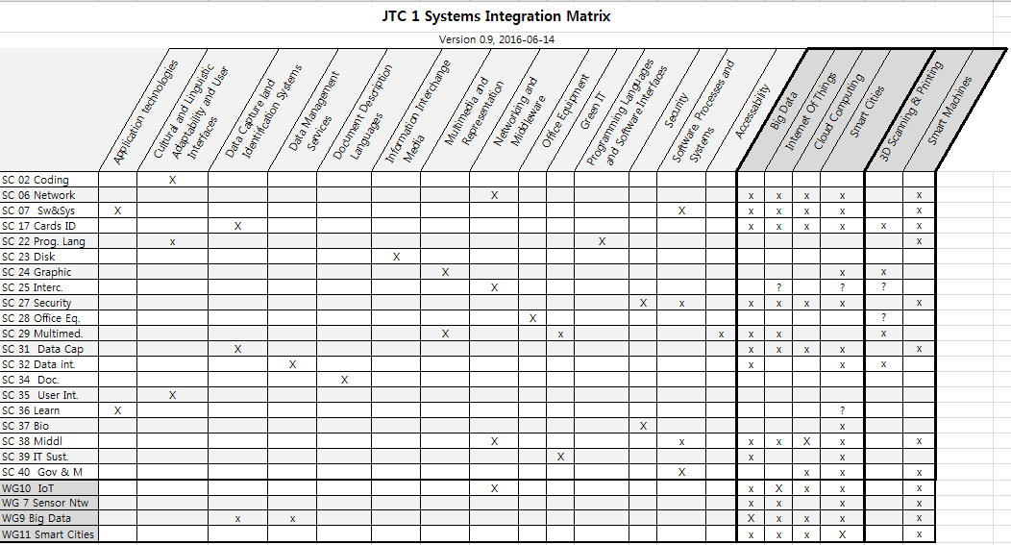
The System Integration Ad Hoc of the SWG-Management (later JAG-SIF) has elaborated this matrix. The diagram document three states: blank – no correlation, ‘x’ weak correlation and ‘X’ strong correlation.

Annex 2 IEEE P3030 - Standard for Consumer 3D Printing: Overview and Architecture
Source: https://development.standards.ieee.org/pub/active-pars?n=10
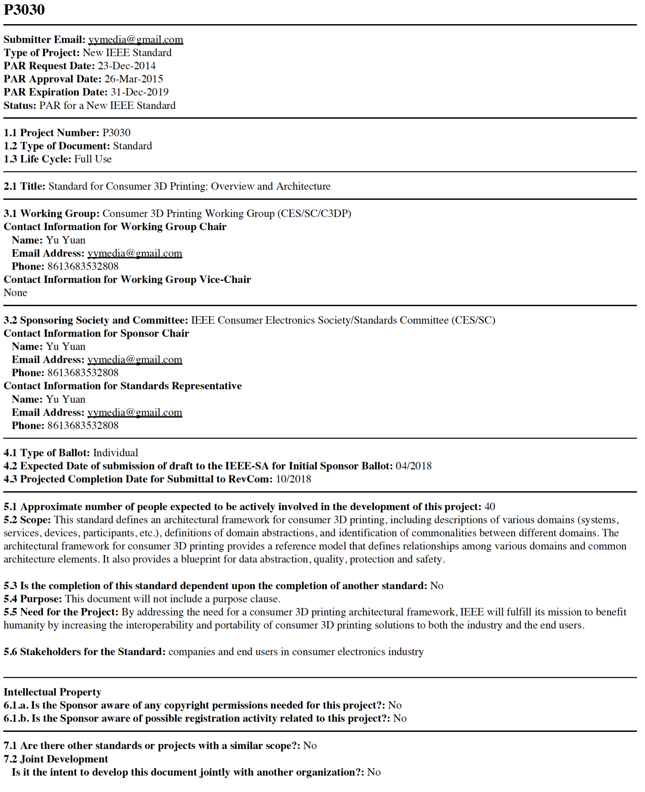

Annex 3 X3D Graphics for CAD, 3D Printing and 3D Scanning
The following point paper was provided to ISO/IEC JTC-1/SC 24 and this JAG for this report.

The Web3D Consortium is an international, non-profit, industry/academia/agency/individual member-supported Standards Development Organization (SDO). Web3D Consortium members create and promote open standards for real-time 3D communication. The Web3D Consortium builds and maintains widely applicable standards through well-coordinated Liaison Partnerships with International Standards Organization (ISO), Open Geospatial Consortium (OGC), World Wide Web Consortium (W3C) and other organizations. Web3D Consortium membership is fully open to industry, government agencies, academia and individual professionals. All Web3D standardization efforts also receive public scrutiny and comment as milestone requirements prior to formal ISO approval as International Standards. Web3D has a Category A liaison with ISO, providing all technical updates to the X3D family of standards for ISO/IEC JTC 1/SC 24.

The X3D Graphics standards include full functional capabilities of the Virtual Reality Modeling Language (VRML) 97 International Standard, ISO/IEC 14772-1:1997 and ISO/IEC 14772-2:2004. Backwards compatibility with VRML syntax is also maintained for all versions of X3D through the X3D Classic VRML Encoding, ISO/IEC 19776-2. A great many tools and applications continue to support VRML import/export and modification, so X3D/VRML consistency provides valuable capabilities for printing 3D models.

The X3D standard includes a CADGeometry Component which supports representation of product assembly structure and face features in X3D scenes. The CADInterchange Profile defined in the X3D standard supports distillation of computer-aided design (CAD) data to downstream applications. Multiple conversions routes from STEP (ISO 10303) exchange files to X3D scenes have been identified, including standalone translation software and web based applications. Commercial CAD applications commonly support export to VRML file format which is a subset of X3D and readily converted to X3D files in Classic VRML or XML encoding. Broad X3D support for Web-based CAD usage continues to be reported regularly during SC24 liaison efforts with ISO/TC 184/SC4.

A recent workshop at the Web3D 2016 Conference has demonstrated consensus on the suitability of creating a combined X3D Profile for CAD, 3D Printing and Scanning. Functional compatibility with other related formats (such as STL, PLY, AMF, and 3MF) provides important design guidelines for this work. Building converters to demonstrate full compatibility is an important part of this work, with many tools already available (e.g. Blender, Okino NuGraf and dozens of other software resources). Current estimates indicate that over 80% coverage is already available for use, and that most additions are refinements to existing capabilities.

Given the broad capabilities of X3D, we are finding that a number of other related technologies are pertinent. Brief descriptions follow.
- Two distinct types of compression are being established for X3D models. The Shape Resource Container (SRC) work by Fraunhofer IGD provides a variety of geometric compression schemes (polygonization efficiencies, quantization, etc.) in concert with progressive-mesh streaming. Through cooperative work between Web3D Consortium and the Khronos Group, SRC is being fully aligned with binary glTF.
- Additionally, cooperative work with the World Wide Web Consortium (W3C) is applying the Efficient XML Interchange (EXI) schema-based compression standard to the X3D XML Encoding. Together these composable approaches are expected to provide unprecedented levels of data compaction and decompression performance, in turn minimizing memory requirements and maximizing processor performance.
- Additional cooperative work with W3C has already applied XML Security capabilities to X3D, including both XML Encryption for privacy and XML Digital Signature for authentication. Of interest is that these standards can each be applied either in whole or in part to an X3D scene document. Current EXI working group efforts include consideration of compatibly applying XML Security standards to X3D scenes that are first reduced using SRC and then compressed using EXI. Such comprehensive capabilities appear feasible and are expected to support a wide range of use cases for secure 3D printing of X3D models.
- X3D includes a document metadata model matching HTML, and also includes a Metadata component which enables embedding of strongly typed metadata anywhere within an X3D scene graph. Current working group efforts are examining addition of a potential Annotation component to facilitate sharable markup and situated display of user metadata annotations. Implementation efforts are especially keen to demonstrate effective integration of ISO metadata libraries suitable for 3D printing, CAD and medical applications.
- Another recent Web3D 2016 Conference workshop has clearly demonstrated the applicability of 3D printing to medical applications, with many models and illustrative examples online as part of the U.S. National Institutes of Health (NIH) 3D Print Exchange (http://3dprint.nih.gov). Current work, performed in part with the DICOM medical imaging standards organization, includes investigation into the suitability of including printable medical X3D models as part of patient electronic health records.
- Of interest is that joint work between SC 29 and SC 24 Working Group 9 on the ISO/IEC JTC1 Joint Ad hoc Group (JAhG) Mixed Augmented Reality (MAR) Reference Model, draft ISO/IEC 18039, which includes the possible use of 3D printed markers and physical objects within MAR spaces.
- The X3D standard is currently in use in the consumer 3D printing market through its adoption in online tools and archives aimed at 3D Printing. 3D printing services offer online uploading of user design files to be printed in a variety of materials. Several of these services, including Shapeways, support submitting user designs as X3D files. X3D offers the advantage over STL format in that it supports multiple colors on a single model; and multiple color printing is now being offered in the consumer market. Online solid modellers now allow consumer users to prepare 3D printing designs using browser-based application, and several of these including TinkerCAD and Clara.io, support exporting a user's design file in X3D format for submission to a 3D printing service. A third component of the 3D printing market is online archives of design files; one popular archive, Thingiverse, directly supports X3D format files.
- The X3D Specifications include language bindings for JavaScript and Java, as well as a newly demonstrated X3D Encoding for JavaScript Object Notation (JSON). Formalization of further language bindings for C++ and Python are under consideration. Current work includes autogeneration of exemplar open-source code for the X3D Scene Access Interface (SAI). We expect that such production of strongly typed application programming interfaces (APIs) for X3D across multiple programming languages, with the likelihood of tuning for small-footprint applications like printers and scanners, is likely to further facilitate the use and interoperability of X3D for printers and scanners.

The Web3D Consortium, through its working groups, public meetings, and open publication of the X3D standards documents, is supporting development of workflows and software conversion and authoring tools to increase adoption of X3D as a standard allowing interchange of 3D content for visualisation on desktop and mobile device screens and for connections with the physical world with 3D Printing and Scanning.

All of these efforts are able to continue progressing coherently thanks to deliberate coordinated efforts by Web3D Consortium participants in concert with formal ISO/IEC JTC1/SC 24 review. Continuing and expanded participation with related ISO/IEC JTC 1 activities is welcome and provides excellent mutual benefit.

Annex 4 Proposed terms of reference for a JTC 1 Study Group
Resolution xx – Creation of a Study Group on 3D Printing and Scanning

JTC 1 recognizes the importance of 3D Printing and Scanning as a trend that will impact the global manufacturing sector, and notes a growing interest in this area among a number of standards setting organizations.
Many aspects of the topic of 3D Printing and Scanning is relevant to the mission of JTC 1 and intersects with the scope of a number of JTC 1 entities.
Therefore, JTC 1 establishes a Study Group on 3D Printing and Scanning with the following Terms of Reference:
Proposed Terms of Reference
- Provide a description of key concepts related to 3D Printing and Scanning, and describe relevant terminology.
- Study and document the technological, market and related societal requirements for the future ICT standardization on 3D Printing and Scanning.
- Study and document current technologies that are being deployed to enable 3D Printing and Scanning.
- Promote the awareness of the importance of JTC 1 activities on 3D Printing and Scanning outside JTC 1.
- Assess the current state of standardization activities relevant to 3D Printing and Scanning within JTC 1, in other relevant ISO and IEC TCs, in other SDOs and in consortia.
- Identify and propose how JTC 1 should address the ICT standardization needs of 3D Printing and Scanning.
- Provide a report with recommendations, and potentially other deliverables, to the 2017 JTC 1 Plenary.
Membership in the SG on 3D Printing and Scanning is open to:
- JTC 1 National Bodies, JTC 1 Liaisons and approved JTC 1 PAS Submitters;
- JTC 1 /SCs, JTC 1/(S)WGs, relevant ISO and IEC TCs;
- Members of ISO and IEC central offices; and
- Invited standards setting organizations that are engaged in 3D Printing and Scanning standardization as approved by SG on 3D Printing and Scanning.

JTC 1 instructs its Secretariat to issue a call for participation in the Study Group.
JTC 1 accepts the offer of the xxx National Body of yyyy to serve as Convenor and xxyy to serve as Secretary for the JTC 1 Study Group on 3D Printing and Scanning.

Acknowledgements
This report was prepared by the ISO/IEC JTC 1 Advisory Group under the direction of Resolution 6 (October 2015 30th JTC 1 Plenary Beijing, China), subsequent Recommendation 11(March 2016 JAG meeting Paris, France) and Recommendation 19(August 2016 JAG meeting Dublin, Ireland).

The following representatives have participated in the work of the JAG group on 3D Printing and Scanning:

François Coallier | Canada
Christophe Mouton | France
Patrick Marchand | France
Satoshi Itoh | Japan
Hwanyong Lee | Korea
Eujin Pei | UK
Kate Grant | UK
Paul Jeran | US
Don Brutzman | US
David Boyd | US
Byoung Nam Lee | Convenor - Korea

This report is open to the ISO/IEC JTC 1 community for review in order that all relevant stakeholders have the opportunity to express their suggestions for JTC 1 future work on 3D Printing and Scanning. This input will be used together with this report for the decision of the November 2017 31st ISO/IEC JTC 1 Plenary Lillehammer, Norway.

Reference: SASAM Standardization in Additive Manufacturing, product diagram courtesy of COMPOLIGHT project http://www.smartlam.eu/index.php/related-projects.html
Alternative file formats exist such as AMF(ISO/ASTM 52915:2016), 3MF (proprietary format) or VRML/X3D (ISO/IEC 14772-1:1997 and ISO/IEC IS 19775-1:2013) cf. ISO 17296:2014 figure 1 – General overview of traditional data flow from product idea to actual part (terminology).
http://www.gartner.com/smarterwithgartner/whats-new-in-gartners-hype-cycle-for-emerging-technologies-2015
http://www.gartner.com/newsroom/id/3117917
https://socialdashboard.com/news/2015-roundup-of-3d-printing-market-forecasts-and-estimates-1
https://socialdashboard.com/news/2015-roundup-of-3d-printing-market-forecasts-and-estimates-1
https://socialdashboard.com/news/2015-roundup-of-3d-printing-market-forecasts-and-estimates-1
http://insights.venturescanner.com/category/3d-printing/
CIE Division 8 is proposing a new TC to define a comprehensive method for evaluation of colour difference between 3D objects and colour reproduction by 3D printing, using both subjective and objective methods.
This information can be found on the “August 13, 2014 BoF slides” link at the bottom of the web page: https://www.pwg.org/bofs.html (accessed on 19/09/2016)
Open Packaging Conventions
AMF(ISO/ASTM 52915:2016)
The Collada Specification was last modified in October 2008 as version 1.5.0 and subsequently approved as ISO/PAS 17506 in March 2013(ISO TC 184 SC 4).
http://www.web3d.org/standards. The Web3D Consortium provides free access to the X3D-related International Standards as allowed by the Cooperative Agreement with ISO

